- First open the email and right click on the image and click COPY IMAGE (see 3rd step for if taking from tiger text)


- Go to your sidebar and click the “ADD” button under MultiMedia Manager

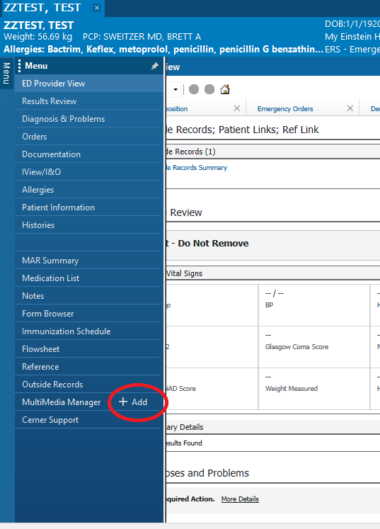

- Click “Paste” on the screen, or if getting from tiger text you can download to your computer then browse for it
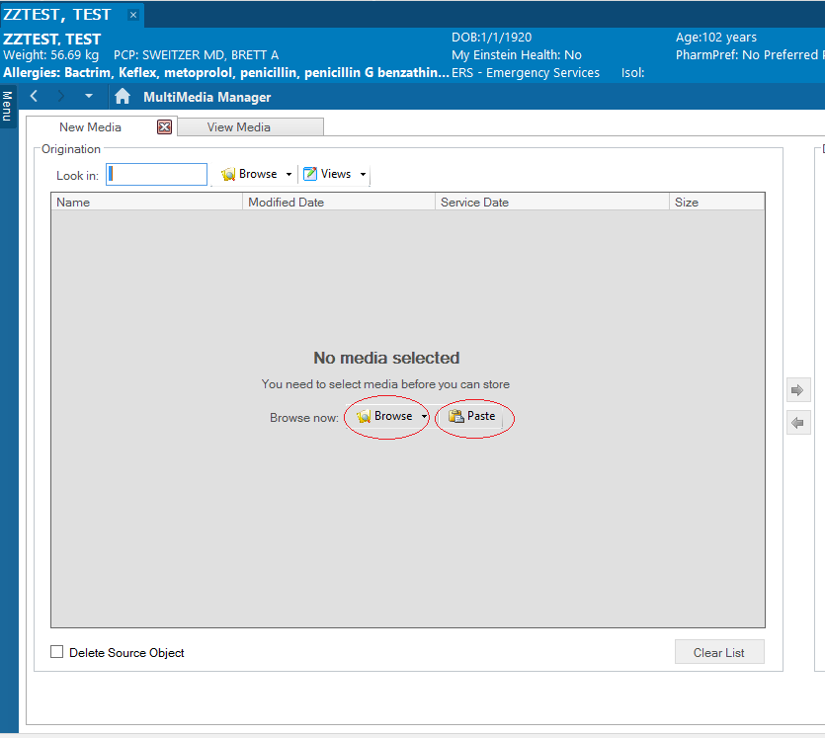

- Once you do that, a white bar will appear with the name of a clipboard document (red arrow)
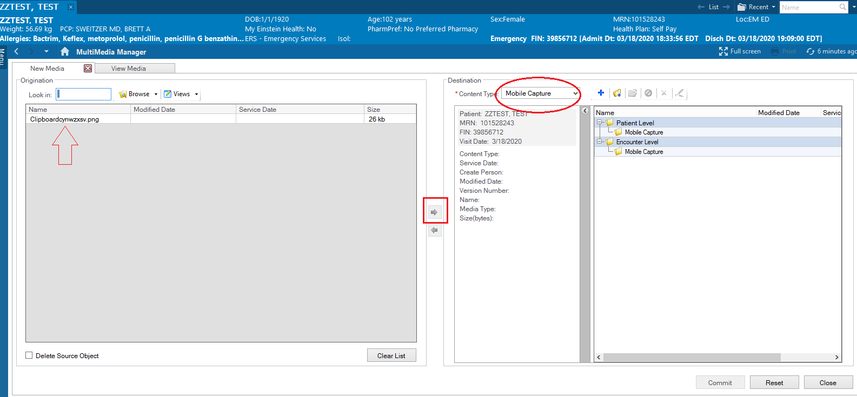
Click on the white bar (above red arrow) and it will turn blue. Make sure that you change the content type (red circle) to either: Clinical Photo, Import Image, Mobile Capture, Patient Provided, Wound Care (these are the only types that can be found later). Once that is done, the right arrow (red box) will turn blue and you can click on it to send it over.

- Once the arrow is clicked, the screen should look something like this:
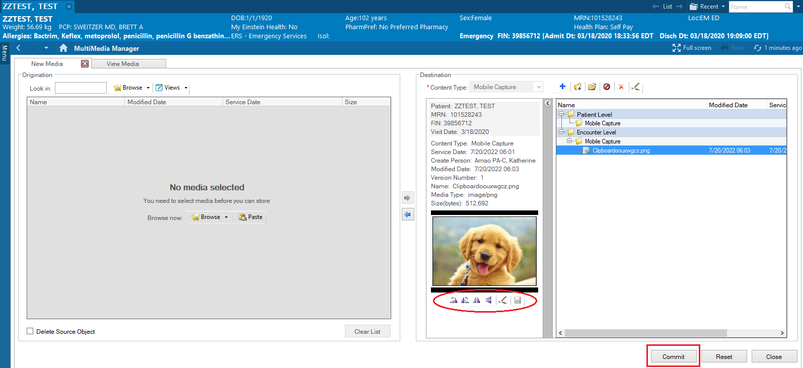
You can then edit (rotate, crop etc…) by clicking on buttons in the red circle then clicking the save button in that same circle. Once done, click the COMMIT Button (red rectangle)

- Then click on ED Provider View
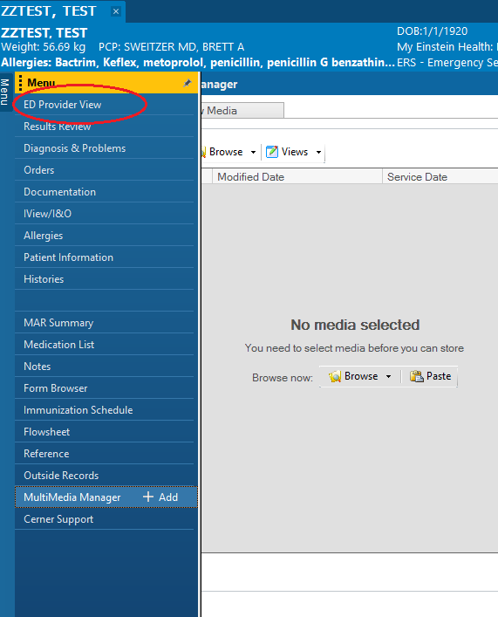

- Then go to the ED Disposition Tab, and then click on Media Gallery
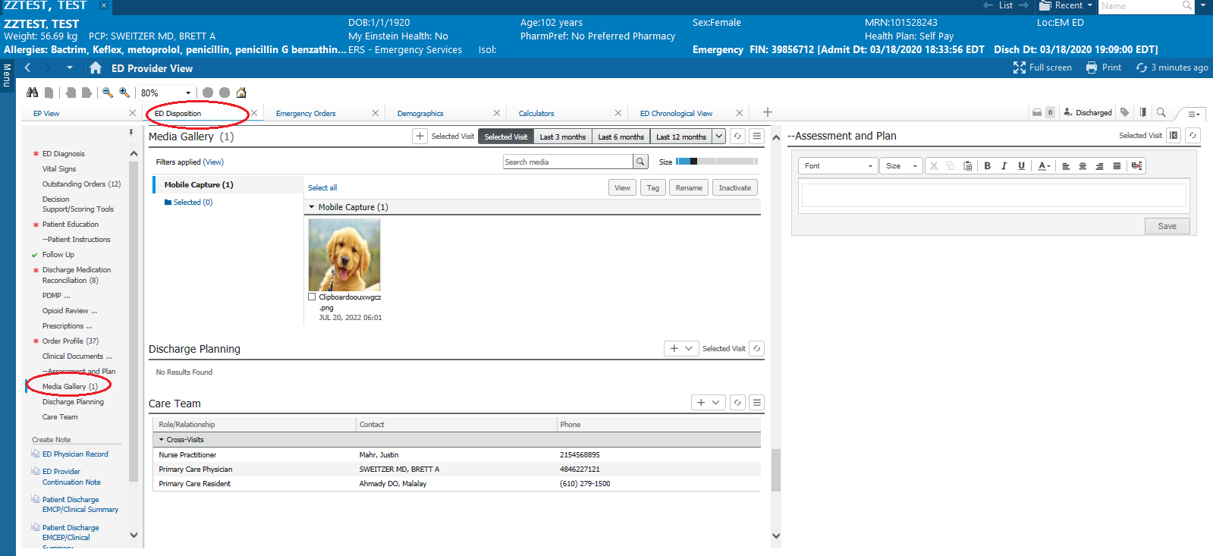

- Click on the picture, then click on the “TAG” button (red rectangle)
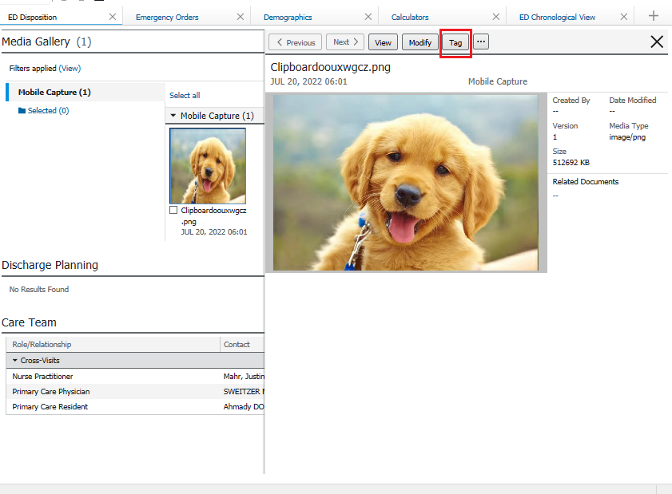

- You then should be able to drag the tag into your document as you would for any other tag to the most appropriate part of your chart
